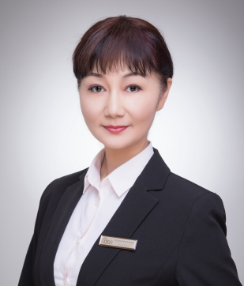

Anna Wang

Anna Wang
Director
Ph 0411 188 629
E: annawang@inlineproperty.com
To achieve the highest level of service for her clients, Anna Wang believes that “professional success stems from having strong values and principles and understanding clients’ needs". She prides herself on her drive to be career-focused, ambitious and she upholds a positive approach and high standard of work ethic.
Anna began her career polishing her sales and communication through hospitality, where she developed her strong work ethic and customer service abilities. She specializes in suburbs: Kew, Balwyn, Box Hill and Mount Albert, and has exceptional ability in selling projects, and this is illuminated by her sales record for Main Drive in Kew. Her customer friendly focused approach is one of the key reasons that allows her to be able to achieve the best possible results and in short period of time. With her personality a work ethic, Anna has developed a strong rapport with her clients and is always aiming to achieve the best for her clients.
Outside of the real estate industry, she is quite a busybee, always love to socialize and excelling in her dance activities. In her past, Anna used to display her dance performances all around the world.
Anna Wang has been in the industry since 2010.

