

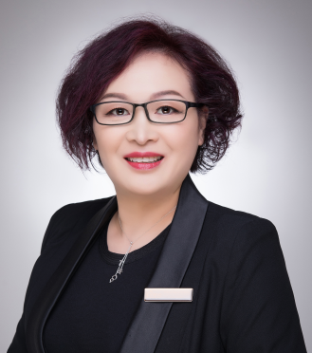

Amy Shen

**Amy Shen**

**Phone 0434 091 122**

**Office 03 8597 4262**

**[amyshen@inlineproperty.com](mailto:amyshen@inlineproperty.com)**

Within seconds of meeting Amy, you sense that her friendly, helpful demeanour is perfectly complemented by her drive, passion and enthusiasm for all things real estate. Extremely hard working and energetic, she has cultivated a reputation as a skillful negotiator.

A highly regarded lnline Director with outstanding leadership skills, Amy's friendly and down to earth professionalism is assured when you contact her for guidance on your important property matters.

Amy as a multilingual agent who speaks fluent English, Mandarin and Shanghainese is gifted with a mutual cultural connection to Asia, making her an excellent bridge for her client.

Office address 695 Whitehorse Road, MONT ALBERT, VIC 3127

Ph (03) 8597 4262

Email: info@inlineproperty.com